Evaluating the Significance of the Desktop Area in Everyday Computer Use
Akrivi Katifori, George Lepouras, Yannis Ioannidis  Department of Informatics and Telecommunications,  University of Athens  Panepistimioupolis , Ilissia, 157 84, Athens, Greece  {vivi, glepoura, yannis}@di.uoa.gr | Alan Dix, Azrina Kamaruddin  Computing Department,  Lancaster University,  LA1 4WA UK,  {a.kamaruddin,a.dix,}@comp.lancs.ac.uk

ABSTRACT
Computers have become part of our homes and day-to-day lives. This paper presents selected results of an interview-based user study focused on information management on the personal computer. We focus on the Desktop, confirming results of previous studies as well as revealing new issues and ensuing design suggestions. With even basic competence users inventively appropriated the desktop, but some features, in particular user-defined shortcuts, appeared counter-intuitive, and were underused. Users are still dissatisfied with their information organization and the challenge is to provide tools that support rather than replace the users flexible and creative use of the current desktop.
Categories and Subject Descriptors
H.5 Information Interfaces and Presentation (e.g., HCI) - H.5.2 User Interfaces
General Terms
Human Factors, Design.
Keywords
Desktop Area, Shortcuts, Desktop Icon Arrangement.

INTRODUCTION
At the dawn of the 21st century personal computers, already present in every business, laboratory, school or public service, are becoming part of our homes. They are starting to assume functions until recently provided by other electronic devices such as cd players, radios, televisions or telephones and it is not inconceivable that in the near future computers will have substituted them. However, the question arises, are current user interfaces really up to this task? Could a computer really be used successfully by almost everyone with minimum instructions or training as a modern television set is?
The desktop metaphor has dominated as means of usage and communication with the computer and its strength cannot be argued as it is an idea easily recognized by everyone. There are on the other hand several problems associated with it, which are partly due to inherent weaknesses present in real world desktop environments, and to the unsuccessful or inefficient implementation of the electronic one. As very few users actually receive formal and organized training on using their computer, in most cases they have to rely on their personal intuition and minimum help and instructions by others. As a result, they tend to develop their own personal style of doing things, which may sometimes seem rather unorthodox, but its study may reveal trends of user behavior as well as ideas for new tools to support personal information management.
Our objective is to attempt to verify and expand results of existing Personal Information Management (PIM) studies through an ongoing user study of computer usage and investigate the creation of new tools to simplify PIM tasks. This work focuses on the usage of the desktop area. The next section briefly mentions related work in this field and the following ones present a description of the study and its results in relation with particular desktop usage issues, followed by a general discussion and the conclusions section.

RELATED WORK
Ravasio et al [3] conducted a user study using semi-structured interviews in order to identify issues and problems of windows based operating systems. They mention several issues related to the desktop area and its use, among which the fact that only expert users could manipulate sufficiently the desktop area. Kamaruddin and Dix have performed a study [1] that investigates issues related to the concept of physicality on Desktop. They confirmed the result of previous studies ([3], [5]) showing that the desktop is used for its reminding function and as a temporary holding area for quick access reasons. They identified groups of users that placed few grouped icons on the Desktop and others that placed almost everything on it resulting into various degrees of clutter.
Barreau and Nardi [4] looked at the types of information managed by users, identifying three types based on lifetime of use: ephemeral, working, and archived. They also noted that the location of information on the desktop serves a critical reminding function.
Malone identified two fundamental strategies in office management: filing and piling [2]. In following user studies several categories of users have been identified, according to the filing strategies they employ. Whittaker and Sidner [6] for e-mail identified no-filers, spring-cleaners and frequent-filers. Boardman studies in [5] how in some cases users change their PIM strategy with the passage of time and also identifies the file-on-creation strategy.
Taking into account the aforementioned results, this work attempts a more in depth analysis of the role of the desktop in everyday PIM activities in relation with user competence and filing strategies. When the results of this study agree or disagree with results of the related studies, it is clearly stated.

METHOD
Up to now a series of 20 semi-structured interviews has been conducted. The duration of each interview was from 45 minutes to one and a half hour. The interviews were conducted at the place were the users work with their computer, either their workplace or their home. They were asked to describe the way they perform certain tasks and organize their documents, as well as provide examples and common practices. They were also encouraged to elaborate on issues that seemed to interest or preoccupy them more or that they found more important and to point out things they would like to be or do differently. User expertise and confidence with the computer as perceived both by the user and the interviewer were recorded. Their answers were noted down and recorded by audio.
At this stage the study has not been focused on a particular user group. Novice and expert users were interviewed in order to gain an insight both to the role of computer expertise in various issues and to the views and problems of novice users. The users interviewed so far comprise a very heterogeneous user group with the following characteristics:
- Gender : female (14), male (6)
- Age Distribution: age 18–25 (3), age 26–33 (14), age 34–41 (2), age 42+ (1)
- Educational Background (1st Degree): Computer Science (9), Philosophy/History (2), Fine Arts (1), Psychology (1), Engineering (1), Primary Education (1), Management (1), Physics/Mathematics (2), Communications (1), Natural Resources (1)
For the needs of this study, the participants were grouped according to their competence when using the computer. The users were rated by the interviewer according to their competence and grouped in three major categories:
Low Competence (L.C.) – 2 users: The users in this category have the minimum skills required to use the computer for basic tasks such as compiling a word document or surfing the web. They lack both in breadth and depth of knowledge of basic desktop tasks like creating or moving a folder, placing items on the desktop etc. The desktop area for them is at the best case a point of access to “My Documents” and to program shortcuts.
Basic Competence (B.C.) – 11 users: The users of this category have a basic understanding of windows operations, enough to allow them to organize their documents in folder hierarchies. They are aware of the uses of the desktop as a temporary or more permanent file repository and are capable of organizing it, adding or removing items from it. They are able to install programs and perform simple maintenance tasks like using an antivirus.
High Competence (H.C.) – 7 users: This category refers to users that have a deep understanding of computer operations, including programming, hardware knowledge and handling complex operating system issues.
As a final remark, the interviews have shown that effective use of the desktop is not only dependent on deep knowledge and understanding but also on imagination and coming up with inventive ways to take advantage of existing knowledge. As a result some basic competence users seem to be more enthusiastic and display more originality with the use of their desktop than some of the high competence ones.
As to the operating system the users used, Windows XP was used almost exclusively with the exception of one Windows 2000. Linux and Unix operating systems were installed in the computers of nine of the participants but only three of them used them as their main operating system, the rest used them for particular tasks only.

RESULTS
This section presents the results of our study related to the Desktop Area along with comments and general observations. A remark that has to be made is that among the twenty interviewed users, not even two of them used the desktop in the exact same way. Everyone seemed to have developed their own way of behaviour towards it. This ranges from treating it as completely transparent, keeping it absolutely void of objects and ignoring it to using it almost exclusively for quick access and have 2/3 of its surface covered. As contrasting were their feelings towards the desktop area, which ranged from: “I hate it, it is a source of disarray” to “I could not live without it”. In the following sections the results of the study are presented and discussed.

Shortcuts
Windows shortcuts seem to be a quite useful and interesting concept, allowing quick access from the desktop to documents and programs. However as Table 1 shows they are not as frequently used as one would expect, with the exception of program shortcuts.

Table 1. Number of users by competence level using each type of shortcut. Folder Shortcuts here refer to user-created shortcuts, not system created ones such as “My Computer”
Type of Shortcut | File | Folder | Web Page | Program
L.C. | 0 | 0 | 0 | 2
B. C. | 0 | 3 | 1 | 11
H. C. | 0 | 1 | 0 | 5
Overall | 0 | 4 | 1 | 19

As seen from the table, only program shortcuts are extensively used by almost all the users. This is probably partly due to the fact that most applications automatically create a desktop shortcut during their installation. The obvious lack of use of the remaining types of shortcuts, namely the file, folder and web page ones, along with the fact that most users very rarely if not ever create a program shortcut shows that the shortcut notion, though useful is not that intuitive.
When prompted on this most users seemed perplexed or uninterested, showing that the notion of shortcuts was strange to them or they could not understand its functionality and use. Bearing in mind the concept of physicality on the desktop as described in [1] and [7] this effect may be explained. As the desktop may be very easily considered as an electronic equivalent of the users’ real world desktop, the notion of items that are not “real” but actually references to other items is not easy to comprehend. Both the shortcut and the item it refers to are represented by an icon and when clicked the same document or program opens. As a result, it is normal that the non-expert users may not distinguish between the two.
The lack of physicality and consequent misuse of shortcuts is not by itself a problem. It becomes a problem, as also noted in [3], when automatically created shortcuts when applications are installed start to clutter the desktop and low and basic competence users feel insecure to delete them in fear of deleting “something useful”. As one user pointed out: “I have to ask my husband who is a computer expert before I delete anything. I’m afraid that otherwise I will do something wrong.”

Files and Folders on the Desktop
Instead of using shortcuts for files and folders they wish to have quick access to through the Desktop Area, most users tend to copy or move the files directly to the desktop. From the twenty participants, the two lower competence ones had not placed any files or folders on their desktop because they did not know that this was possible. However, contrary to the results of [3], 9 out of 11 basic competence users had user created files or folders placed there. Of the two that did not, the one shares the computer with the rest of the members of her family, using the same desktop area, and they have decided to avoid placing files there, whereas the other considered it “unnecessary” and “untidy”. Six out of 7 high competence users had files or folders created on the desktop.
The users gave three reasons for placing items on the desktop, which are, as previous studies ([1], [3]) also suggest, the following:

Quick Access to Programs and Working Files
The Desktop is the first thing visible to the users when they switch on their computer and, as a result, by many it is used as a means to gain quick access to programs and files. In order to minimize the mouse clicks necessary to locate the desired item, users tend to use program shortcuts and move or copy items on the desktop. When asked what kind of items they prefer to have on their desktops, most users responded that they prefer to have frequently and/or currently used ones.
As already mentioned program shortcuts are present in almost all desktops and are used by most users. These are mostly desktop shortcuts to programs that are of almost everyday usage like web browsers, web connections and DVD players. For other kinds of programs like word processors or development tools most of the users prefer to use the Start Menu.
On the other hand, the choice to place shortcuts on the taskbar seems to be ignored by the majority of users. Only four expert users use this function in order to benefit from the “one click” possibility. Most users seemed to ignore it completely, so it could be assumed that its misuse is more due to ignorance than anything else. Of the users that used it, one even stated that she uses a two-line taskbar in order to have more items available on it and that she finds it very convenient..
Four users keep frequently used files and folders on the desktop in order to access them directly when needed. Ten users stated that they sometimes place the files or folders they are currently working with on the desktop. After their work with these files is completed they move them back to their original location or file them to a new location. This movement of files to and from the desktop, although not as practical as using shortcuts seems to be more natural to the users, just like placing the papers they are currently working with on their real world desktop. One of the users consciously understood the desktop metaphor as an electronic equivalent of her real desk and stated that: “I place files there as I do with my desk.” Another had a very organized folder structure on the desktop especially for his currently working files.

Reminding
Another function of the Desktop Area mentioned by some of the participants was reminding. They explained that sometimes files are placed there not only for quick access but also to remind them to process them or to do a particular task, as it has already been noted in previous studies [1] [4]. This task may be an action performed on the file itself, for example edit it or delete it, or it may be an action relevant to it, like putting it in a CD and giving it to someone.
In some cases, however, when the action has been postponed for a long time, the purpose of these files tends to be forgotten and they remain as unknown or ignored items and, as a result, a source of clutter. As one of the users explained for a group of files on her desktop: “These were put here a long time ago to remind me to give them to a friend but after all this time I’m not sure if I’ve given them or not and what to do with them…”
Another interesting practice mentioned by some of the users was to keep a “To Do” list on their desktop as a directly accessible and constantly visible reminder of tasks they had to perform. However, this list requires effort in order to be maintained up to day and does not automatically remind the users of the exact time or dead-lines to perform certain tasks.

Downloads and Incoming Files to Be Processed
Apart from being a place to keep currently or frequently used files, the desktop is also sometimes used as a temporary storage area. Ten of the interviewed users described as a common practice to first place on the desktop files coming from outside sources and later filing them to their proper location.
Four users explained that they mostly follow this practice due to the fact that the default download location of the Mozilla Firefox web browser is the Desktop. Curiously, these users preferred performing this task instead of changing the browser download location to another one. Reported reasons for this were ignorance of the possibility to change this location or unwillingness to find the way to do so. However, they seem to find this method convenient enough, it does not bother them. One user even suggested that initially he had his downloads placed in a separate folder but decided to change the download location to the desktop again in order to be reminded to deal with them.
Four of the users stated that they sometimes prefer to copy items first on the desktop when they are provided to them through a removable media like a CD or a USB stick as it is more convenient especially when they are in a hurry. Again, it is intuitive to the users to place new papers and material firstly on their desk in order to file them away later.
Only one of the users seemed to disagree with this idea and described the desktop like “a drawer where you pile things you don’t want to process in the near future, but do not want to throw away either”. For her, the top level of the ‘My Documents’ folder played the quick access, temporary storage and reminding roles assigned most often to the desktop. This particular user expressed a high dislike for the desktop. She felt that it is “useless” and a “source of disarray”. As she put it “I’d rather it did not exist!” The reason for her strong feelings on this was undoubtedly desktop clutter.

Desktop Area Filing Strategies
For the needs of this study, the users have been grouped in four categories according to their filing strategy in respect with the desktop. These are: no filers, frequent filers, instant filers and spring cleaners [6]. The term “instant filer” has been introduced to characterize the users that immediately place files in their appointed location as opposed to “frequent filers” who may do it once in a few days. “Spring cleaners” on the other hand are considered those that “clean – up” their desktop, filing away items, once in a few months or when it becomes really cluttered. The distribution of the users of this study according to this categorization is summarized in Table 2.

Table 2. Number of users by desktop related filing strategy
Filing Strategy | No filer | Instant filer | Frequent filer | Spring Cleaner
L.C. | 2 | 0 | 0 | 0
B.C. | 0 | 4 | 5 | 2
H.C. | 0 | 3 | 3 | 1
Overall | 2 | 7 | 8 | 3

Instant Filers undoubtedly presented the most organized and tidy Desktop Area. Their desktops had very few icons on it, mostly program shortcuts and in some cases some files and folders that, as they explained, they were supposed to be there because they were frequently or currently used. Three of these users had a few files which, as they stated, “they are not supposed to be here”, mostly downloads to be sorted out later in the day. Most of the Instant Filers seemed to be satisfied from the state of their desktop, it felt and looked “tidy enough”, however at least three of them felt that they are not as organized as they should be because they still have problems locating their files.
Frequent Filers and Spring Cleaners presented a rather more untidy desktop. Apart from permanent icons, there were icons that in some cases the users stated were not supposed to be there and in others they did not even know what they were. As time passes and the number of such unused icons increases the desktop becomes more cluttered, an issue commented in the following section.

Desktop Clutter and Disarray
As is the case in the real world desktop, “piling” documents on it for various reasons may result in a desktop area full of items in various degrees of disarray. This problem has been identified in previous studies [1], [3] as the result of the usage over time of the desktop as a temporary file repository and is characterized by most basic and high competence users as a source of varying degrees of distress. Their feelings towards this issue were very much related to their notion of tidiness and affected their employed filing strategy with desktop items.
The boundary after which users seem to consider their desktop cluttered seems to vary considerably. One user for example allows only the Recycle Bin on her desktop whereas another decides to tidy up if more than 2/3 of the desktop is covered with icons. Clutter seems to be “visually distracting” and “dizzying” for most of the users and it is the most common reason that they re-arrange and tidy – up their desktop.
Another issue noted in some of the users is that while they presented their desktop, they seemed to consciously or subconsciously ignore certain files, folders or programs. When their attention was brought to this fact they answered that they were not really sure what these things were. They vaguely remembered that they placed them there or that they appeared after the installation of some program but, as they said, they got used to them and started considering them part of the background and, consequently, ignoring them completely. One comments on a pdf “forgotten” on her desktop: “I got used to it being there. I am a visual type and I don’t think I will be able to retrieve it when I will need it if I move it someplace else”.
“Tidying up” is accomplished by browsing through each one of the dumped or unknown items on the desktop and deleting them or filing them in their appropriate place. Although this action is very similar to how piles of documents are filed away in the real world desktop, in the computer desktop the situation seems to be a bit more time consuming. In order to just browse the contents or title of the document to be reminded of what it is, the users have to open it with the appropriate application. If this process has to be repeated for ten, twenty or more documents, it tends to frustrate the users. As one user stated, “OK, it obviously bothers me that my Desktop is in this state but I really don’t have the time to see what all these things are and decide where to place them”. Another said: “It is awful, the desktop is a source of untidiness, I don’t know what some of these things are and I am bored to deal with the rest”.

Arrangement of Icons on the Desktop
Ravasio et al [3] suggest that users tend to separate on their desktop working, ephemeral and archived items. This separation was not evident in our study, as the desktop is only used as a location for working and ephemeral items by some users, whereas very few keep archived items on their desktops. Users, on the other hand, most commonly applied a grouping technique based on thematic proximity and document type, also recorded in [3].
In relation to the arrangement on desktop, three general categories may be identified (Table 3). The “None” category includes the two novice users who do not consciously rearrange their desktop, users that avoid leaving user created icons on the desktop but also do not change the default arrangement and the ones that pay no attention to icon arrangement and only delete icons when they consider the desktop cluttered.
Table 3. Number of users by desktop file arrangement
Desktop State | None | Yes, no grouping | Yes, with user - defined icon groups
L.C. | 2 | 0 | 0
B.C. | 2 | 4 | 5
H.C. | 1 | 1 | 5
Overall | 5 | 5 | 10

The second category refers to users that make a conscientious effort to keep their desktop tidy but are not really interested in creating any kind of special grouping in respect with the icons they maintain on the desktop. These users most often manually or automatically arrange their icons in columns, usually at the left side of the desktop. Four of them reported to use the Windows “Arrange Icons By” command. The fifth explained that she places new items on the desktop from left to right in consecutive columns. When rearranging and desktop items are deleted or filed away, she moves everything to the left to eliminate empty “spots” in the columns. This is the reason why, as she stated, “more permanent icons are located to the left and more temporary to the right”
The third category of users tends to arrange their desktop icons in small groups, usually according to obvious or not so obvious common features. Program shortcuts were almost always a separate group, either all together or divided in sub-groups. The reported desktop arrangements may be grouped in two general categories:
1. Temporary vs. permanent item distinction. (4 BC, 2 HC users). Users of this category invariably used the left side of the desktop for permanent items, program shortcuts or folders, and the right side (in some cases also top or bottom) for temporary and working items. This tendency, as also suggested in [3], seems to be partly reinforced by the fact that this is the default location these icons appear in Windows. Two of the users placed some program shortcuts also in the right side and two had the Recycle Bin at the lower right corner, as it came with the Windows installation.
2. Thematic proximity distinction (2 HC, 2 BC users). Users of this category group icons according to their use. Again the default icon placement seems to be of importance as My Computer and Program Shortcuts were mostly at the left side. Other clearly defined sections identified in some of the user desktops were Internet related icons (browsers, connections, ftp clients), Music and Video applications, downloads and working items.
The tendency of the users to use symmetric forms noted in [3] is confirmed by our study. Lines, mostly vertical but horizontal as well, are very commonly used. Rectangular placement of icon groups is also evident. The lines of icons at the sides of the desktop may be explained as the result of the effort of the users not to obscure their desktop background image, used by most users, and to minimize visual clutter. In the cases where more than two icon groups were present, users seemed to avoid creating lines at every side of the Desktop, preferring rectangular groups of icons instead. One H.C. user even suggested that at some point he had found useful to use a background image with rectangular areas painted on it by him, in order to distinguish the icon groups he created.

Desktop Aesthetics
As the desktop area is the most “direct” and “visible” part a Windows based operating system, making it visually pleasing seems to concern the majority of the users. The Desktop background picture seems to be of particular importance to most users. They choose a theme that is related to their interests, is aesthetically appealing or has a particular sentimental value. Table 4 presents the desktop themes chosen by the users.
Even those not concerned with choosing an appealing background, consider it important to keep the desktop tidy. Otherwise they feel it becomes “dizzying” and “visually distracting”. As already noted in the previous section, most users avoid placing icons in the central parts of their desktop in order not to occlude the desktop background.

Table 4. Selected desktop background themes
Background Theme | LC | BC | HC | Overall
None | 1 | 1 | 1 | 3
Windows Default | 1 | 2 | 1 | 4
A Windows Background (not the default) | 0 | 1 | 2 | 3
Picture provided by user (nature photos, fantasy pictures, pets, etc.) | 0 | 7 | 3 | 10

Not so surprisingly, the two interviewed graphics designers seemed to be more conscientious to this respect, explaining how they change the background often, according to their mood: “My desktop is black, because it is neutral, relaxing and contrasts with the icons. The image is not full-screen because it conveys freedom and seriousness. It is changed automatically 3-4 times a day. If I do not like it I change it myself. I prefer exotic island pictures.”

DISCUSSION
Building on the issues already discussed, more general issues are presented in this section along with some suggestions for potential tools.
1. Users dislike putting much effort in organizing. An important but rather expected result of this study is that the majority of the users tend to avoid putting much effort in managing their desktops and keeping them tidy. They seem to build their desktop icon arrangements around the default ones. This suggests that the automatic placement of the icons should be carefully designed, based on studies on what the users believe more convenient or even given as an option during the operating system installation.
2. Users tend to blame themselves more than the system. A very common answer given by the users when asked if they had any suggestions on what could assist them in organizing their files was that there is nothing wrong with their computer and that it is they that should be more organized. This user reaction suggests that the desktop area as a metaphor of the real world desktop seems to be rather successful. Contrary to [3], which states that only expert users may successfully manipulate the desktop area, our study showed that the majority of the interviewees understand it and use it efficiently. On the other hand, the electronic desktop, like the real one, has a tendency to clutter. It seems to attract piles of documents, very soon transformed to unknown icons. The users then have to dedicate time and effort to make their desktop once again tidy.
As most of the users pointed out, this situation could be avoided if they were more organized, but in some cases when the users are under time pressure and they have to deal with many files, it is very difficult to make instant filing a priority and they end up simply leaving the item with the intention to file it away later. In this case, tools that take advantage of semantic information in order to aid filing and retrieval would be useful.
3. Users do not understand shortcuts very well. As already mentioned, although the desktop as a metaphor seems successful, Shortcuts are not. Basic and low competence users have problems understanding their meaning. They treat them as normal files and are reluctant to delete them even though they do not actually need them on their desktop and this fact is sometimes a source of frustration when newly installed applications create icons on the desktop.
As the newest versions of operating systems seem to more and more hide complexity and try to discourage the user of searching too deep into the operating system functions, it is natural that these issues appear. As it has already been mentioned, most users do not receive any kind of formal training relevant to Windows usage and, as a result, the users have to explore by themselves the operating system and sometimes feel helpless as the system seems to make decisions for them which they cannot easily undo.
4. Users use spatial arrangements on the desktop. One simple idea is the one suggested by one user in our study and also mentioned in [3], which is to provide the user with tools to create divisions on the desktop area in order to place there specific groups of icons. This way, a user could create a specific downloads area at the right or current files area on the top. The operating system could support this automatically by assigning different parts of the desktop to different kinds of icons, for example program shortcuts to the left, downloads to the right.
Furthermore, as some of the users explained, after leaving an icon at a specific position for some time they are reluctant to move it because they are afraid they won’t be able to retrieve it. This fact implies the existence of a spatial memory as to the function of specific items in specific positions. Users that have realized its importance sometimes prefer a less tidy desktop and folder hierarchy to filing away files that they got used to in a specific place and then forgetting where they are.
It would be interesting to investigate to this end the use of icons that carry with them their positioning history and allow the user to search for them according to the places they’ve been. Users could also have the option to see files as “ghosts” in their previous position and be able to access them through these semi-hidden shortcuts.
5. Users are sometimes inventive. Leaving aside possible shortcomings, the desktop seems to offer possibility for many different arrangements and in some cases inventive and imaginative organizations. Placing for example frequently used items at the very edges or corners of the desktop area, in order for them to be accessible even when many windows are open on the desktop. Or arranging their desktop icons in the appropriate groups and places in order to remind or urge them to do things, like “the closer I place these icons to the Recycle Bin, the more I feel I should process them or throw them away as soon as possible.”
Allowing the users this freedom is certainly a good feature as it gives them a sense of creativity and accomplishment, a sense of “playing” with the computer, which some of the users seem to enjoy, as they explained. This does not mean however that support should not be provided for those that either do not have the time or the will to play with their desktop in order to maintain it.
6. Users need support with tidying up. The problem of clutter and its consequences have been extensively mentioned in previous sections. It would be interesting to investigate the use of a tool to support the task of desktop clean-up, which would probably be an enhanced version of the Windows XP Desktop Cleanup Wizard. Currently the wizard identifies unused icons and suggests their deletion. However, this is not by itself enough when the user does not remember what some of the icons are. In a case of a file that should have been archived but somehow it has been left on the desktop for a few months after it was copied there from an outside source, it is not helpful just to mark it as “Never Used”. The date of last use, its provenance and a preview of its contents could be used as a reminder of its contents. Such a tool would help the user to quickly go through all the desktop icons, deleting or filing away when necessary.
Taking into account possible user defined spatial arrangements; the tool could also propose possible locations for filing away the unused icons, like suggesting the “Downloads” folder when the icon is situated on the desktop part that is dedicated to downloads.
7. Users recognize the desktop reminding qualities. The reminding function, quite powerful due to the visual directness of the desktop, should be investigated more thoroughly in order to create desktop related reminding tools. While most users recognize the reminding qualities of the desktop, few know about or use any kind of tool (electronic Post-It, calendars) to this end. It seems that if such tools are not seamlessly available with the operating system and very easy to use, most users, especially basic and low competence ones, will not even be aware of their existence. They will rather tend to invent their own, personalized ways of reminding, only using the existing desktop facilities.
8. Users Appropriate and Reflect. While not all the users understand the full functionality of the desktop, shortcuts etc, the range of individual ways in which they use it shows they were able to appropriate it. While appropriation is widely recognized as an important phenomenon, there is little in the way of practical design advice. One simple rule is to deliberately include elements that are not interpreted by the system, so that users can create their own (individual or shared) interpretations. In the case of the desktop icon location this is satisfied thus allowing users to create their own structures.
Not only do users appropriate the desktop, but in many cases they are aware of the emergent or planned patterns of movement and adapt them explicitly. This is particularly obvious in the case of the user who created a temporal ordering by adding files to the end, even though this required considerable work. This meta-cognition suggests that users are able to effectively make use of complex organizations if they are given the appropriate environment. This suggests that given a suitably flexible way (such as marking areas of the desktop), users may be able to communicate some of their organisational structure back to the system, for example “icons in the top right need action” so long as this does not compromise the openness that made appropriation possible.
9. Users Respect Physicality. The desktop suggests a physical metaphor and this is undoubtedly one of the reasons users are so easily able to appropriate it in such individual ways. However, this is also one of the reasons the non-physical notion of shortcuts is difficult to understand. A major design challenge is how to allow users access to the computational power of a ‘virtual’ environment, whilst still leveraging the cognitive power afforded by a physical metaphor.
This may be related to the apparent conflict several researchers have noted where users suggest that they would like to be able to multiply classify items, but when given tools to do so rarely use them: putting a single file ‘into’ several folders is unphysical. In contrast tagging systems are clearly popular and intuitive: in the physical world a file can have many labels written on it, but only a single location. Furthermore a label in the physical world is already a more ‘virtual’ concept; one can imagine all the documents with a label, even if they are not in the same location.

CONCLUSIONS
We have presented results of a study of the usage of the computer desktop by users of varying competence. In many areas we have found similar results to previous studies, but also have noted behaviors that, whilst almost certainly present in earlier cohorts, have not so far been brought to attention.
Whilst we noted some differences related to competence, once a basic level of competence had been reached we instead saw a wide range of ways of using the desktop that did not correlate with expertise. In particular we noted that there was minimal use of shortcuts, despite the fact that almost half the sample have computer science background, which we attribute to the conflict between the shortcuts and the physical model of the desktop.
Non-functional aspects such as feelings of tidiness and clutter and also decoration of the desktop were important to many users – the personal computer is not just there to do things but it is also a ‘place’ people spend time. The ability to freely spatially organize the desktop both allows clutter but also allows personal expression. In addition the uninterpretted nature of desktop space has allowed user appropriation and we saw emergent layouts and behaviors.
Despite the way in which users make the desktop their own, they still have considerable trouble managing this and the rest of their filing systems and frequently are dissatisfied. In seeking solutions to this, we can perhaps take lessons from their successful organization strategies and seek ways to amplify rather than replace them.
We are continuing interview-based studies on other aspects of personal information management: file and folder structures, search and browsing, e-mail and bookmark hierarchies. The ultimate aim is to aid us in the design of more effective organization tools. We aim to produce envisionments/prototypes of some of the design features suggested during the discussion in this paper: marking areas of the desktop and maintaining “where I’ve been” history for files. In addition, this work will contribute to plans for alternative ways of organizing information items using labels from personal ontologies.

REFERENCES
- Kamaruddin, A., and Dix, A., Understanding Physicality on Desktop: Preliminary Results. Physicality 2006, 6-7 February 2006, Lancaster.
- Malone, T.W. (1983) How do People organize their desks? Implications for the design of office information systems. ACM Transactions on Office Information Systems 1(1):99-12.
- Ravasio,.P., Guttormsen,, S., and Krueger, H. In Pursuit of Desktop Evolution: User Problems and Practices With Modern Desktop Systems. ACM Transactions on Computer-Human Interaction, Vol. 11, No. 2, June 2004
- Barreau, D., and Nardi, B. Finding and Reminding:File Organization From the Desktop. SIGCHI Bulletin (1995) 27.
- Boardman, R. and Sasse, Mt. A., “Stuff Goes into the Computer and Doesn’t Come Out”: A Cross-tool Study of Personal Information Management. CHI 2004, 24-29 April, Vienna, Austria
- Whittaker, S. and Sidner, C. 1996. Email overload: Exploring personal information management of email. In Proc. of CHI’96. ACM Press, 1996.
- Ghazali, M. and Dix, A., Knowledge of Today for the Design of Tomorrow. In Proc. of the 2nd International Design and Engagibility Conference (IDEC) 2005 Proceedings, Edinburgh, 6th September 2005

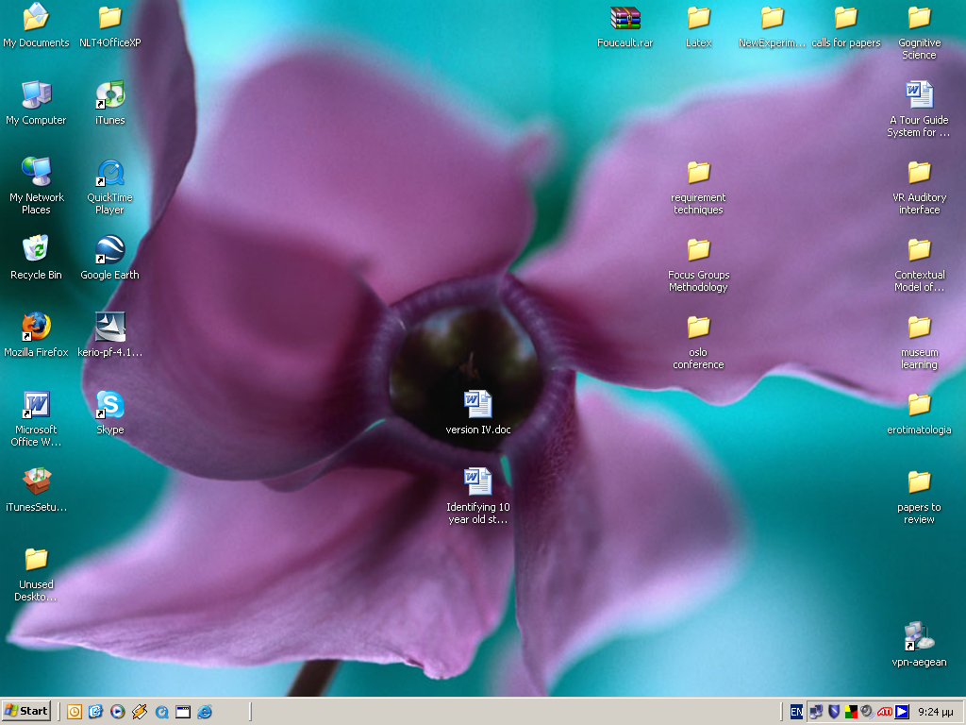
Figure 1. An example of temporary vs permanent icon grouping. Note permanent items on the left and working items on the right. Items in the middle are temporarily there, to be processed the same day and filed away, deleted or placed on the right with the rest of the working items.
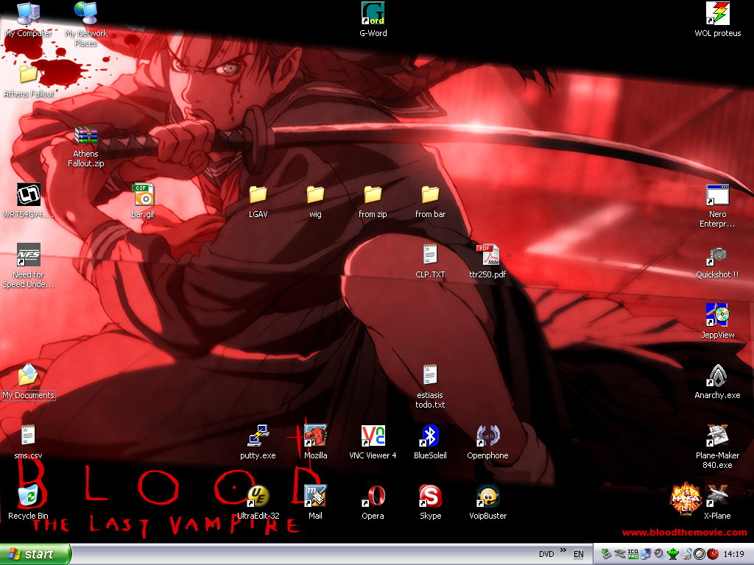
Figure 2. An example of thematic proximity grouping. Drives, Recycle Bin, etc, are placed on the left, Internet related icons on the bottom and other applications on the right. The icons on the middle are downloads from the web or other external sources (usb stick) to be processed during the day. Note a “to do” text file on the middle – down section of the Desktop.

